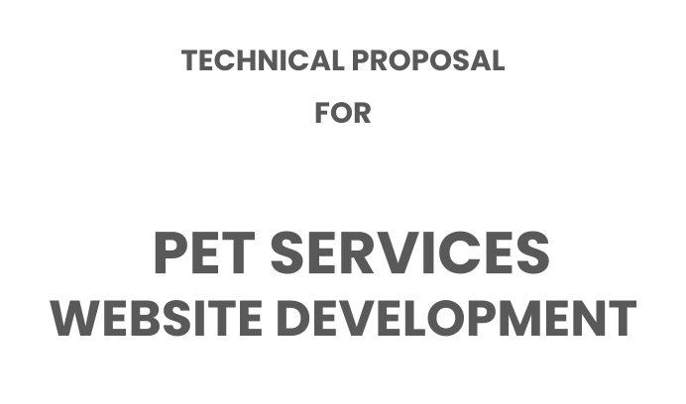

#### Version : 1.0

Date : 19 May 2025

Submitted for :

#### Mr. Kush Chaddha

Submitted by:

Sameer Patel Markup Marketing

308, Corporate Road, Ahmedabad India [biz@siegpartners.com](mailto:biz@siegpartners.com)

### Cover Letter

Dear Mr. Kush,

Thank you for the opportunity to present our Technical Proposal for the Hero Pet Care Service Portal. We truly appreciate your vision of creating a community-driven, pet-sharing platform that promotes trust, companionship, and responsible pet care.

Based on our discussions and research—including a detailed study of successful platforms like *BorrowMyDoggy*—we have crafted a robust technical framework that aligns with your goals. This proposal outlines our understanding of your requirements, suggested platform features, user roles, technical options, and implementation strategy.

Key highlights of the proposed solution include:

* A secure, multilingual, and mobile-friendly platform supporting English and Russian.
* Advanced pet matching, availability calendars, real-time chat, and a flexible booking engine.
* Tiered subscription management, trust and safety features, and an education center for users.
* Scalable backend architecture using either PHP Laravel or

Node.js, with pros and cons outlined for informed decision-making.

We are confident that our solution will deliver not only a technically sound platform but also a delightful experience for your end users. Our team is excited about the prospect of contributing to this meaningful initiative that blends technology with animal welfare.

Thank you once again for considering Sieg Partners as your technology partner.

Best Regards, Sameer Patel Sieg Partners

# Objective

To build a secure, scalable, and multilingual Pet Borrowing Platform that connects pet owners (Pet Parents) with pet lovers (Pet Friends) for responsible pet care sharing through a structured, real-time-capable, and subscription-driven system.

# Target Audience

1. Pet Owners who need reliable support when unavailable.
2. Pet Lovers who want part-time companionship without full-time ownership.
3. Students & Professionals living alone or in rentals.
4. Families exploring pet ownership before adoption.
5. Animal Welfare Communities supporting shared pet care.

# Platform Goals

* + Build a trusted ecosystem with verified users.
  + Enable structured, secure pet borrowing experiences.
  + Allow multilingual support (English & Russian).
  + Promote responsible pet interaction through education.
  + Offer monetization via tiered membership plans.

# User Roles & Responsibilities

#### Pet Parent (Owner)

* + Create/manage pet profiles.(Option to add photos and videos if the)
  + Set pet availability and preferences.
  + View and approve/reject borrow requests.
  + Search for pet fiends and make booking request
  + Chat with borrowers.
  + Post experience-based reviews.

#### Pet Friend (Borrower)

* + Create personal profiles with preferences and experience.
  + Search and filter available pets.
  + View and approve/reject requests from pet owners.
  + Send borrowing requests.
  + Receive approvals and initiate chat.
  + Submit reviews post-visit.

#### Administrator

* + Approve/manage users and listings.
  + Monitor communications and bookings.
  + Handle disputes and feedback.
  + Push announcements.
  + Manage CMS, payments, and analytics.

# Feature Set – Detailed Overview

#### Pet Listing & Profile Management

* + Pet Parents can list multiple pets with attributes: breed, photos(can we add video too? Not mandatory) medical notes, care tips.
  + Tags for services (dog walking, boarding, etc.).
  + Availability status: Available, Booked, Temporarily Unavailable.

#### Calendar Integration

* + Both roles manage availability using intuitive calendar tools.
  + Support for hourly (2hr/4hr) and daily slots.
  + System prevents double bookings.

#### Advanced Search & Filtering

* + Filter pets by type, breed, age, size, location, temperament, availability.
  + Location-aware suggestions (Google Maps-based).
  + Browse in list/grid view with direct booking options.

#### Matching System

* + Suggest matches based on profile similarity, distance, availability.
  + Borrowers and Owners can save/favorite matches for later.
  + sending notifications (push, email, maybe something else)

#### Secure Chat & Messaging

* + Post-approval chat access.
  + Real-time messaging with file/image sharing.
  + Admin moderation tools to report/block abuse.

#### Profile Verification & Safety

* + Email & phone verification for all users.
  + Optional document verification (for premium trust badge).

Insurance coverage info for bookings (client to manually manage provider)(Applies automatically to all the active bookings)

* + .
  + Vet support hotline info displayed to premium users(Applies automatically to all the active bookings).

#### Subscription & Membership System

* + 3-tier plans for Pet Parents and Pet Friends.

Plan-based feature access (e.g., chat, booking limits, education center)(All plans give access to all features).

***2025-05-22 20:47:51***

--------------------------------------------

Automatically access to all active bookings.

* + Secure payment gateway (Stripe, PayPal, Razorpay).

***2025-05-22 20:44:38***

--------------------------------------------

Applies automatically to all the active bookings

* + Auto-renewal and email reminders.

#### Review & Rating Module

***2025-05-22 20:49:05***

--------------------------------------------

All plans give access to all features

* + Mutual reviews after bookings.
  + Star-based ratings visible on profiles.
  + Reviews editable for 7 days.

#### Education Center

* + Post-login access to blogs, videos, and how-to guides.
  + Categorized by pet type, care needs, safety, and FAQs.
  + Admin-managed content hub.

#### Notifications & Alerts

Web and email notifications for:

* + Booking updates
  + Chat messages
  + New pet listings
  + Profile changes
  + Admin can broadcast system alerts or announcements.

#### Admin Panel (Full CMS)

* + View/manage users, pets, reviews, and subscriptions.
  + Handle disputes, manage content/blogs.
  + Track payment records and user engagement stats.

#### Technology Options

You may choose between the following two robust frameworks for development:

##### Option A: PHP Laravel

Pros

1. Rapid development with elegant MVC structure.
2. Built-in tools for authentication, routing, and security.
3. Strong community support and documentation.
4. Easier integration with MySQL.
5. Ideal for platforms prioritizing structured backend workflows.

Cons

1. Requires additional services/tools for real-time features.
2. Slightly less optimized for concurrent events (e.g., chat).

##### Option B: Node.js + React.js

Pros

* + Event-driven, non-blocking model ideal for real-time apps.
  + Built-in WebSocket support for live messaging.
  + React.js enables dynamic, fast-loading, mobile-first UIs.
  + Highly scalable; easier future transition to mobile apps.

Cons

* + Slightly longer backend development cycle than Laravel.
  + More effort required in authentication and security implementation.

#### Project Flow

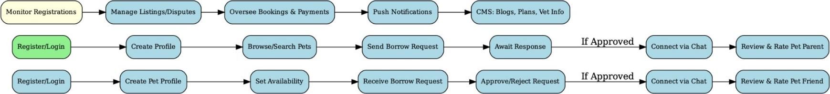

Benefits of This Solution

* + Connects passionate pet lovers with pet owners in need.
  + Promotes responsible pet sharing.
  + Encourages trial adoption.
  + Supports monetization via subscriptions.
  + Enables localized pet care help with trust and safety.

#### Future Roadmap (Optional Phase 2+)

* + Mobile Application
  + Referral/Rewards Program
  + Pet Product Ecommerce Marketplace
  + In-App Video Calling (via 3rd-party API)
  + User Activity Dashboard & Reporting
  + Vet Online Consultation

## Prerequisites (Client Responsibilities)

* + Finalized branding (Logo, Color Palette)
  + Subscription plan structure
  + Vet partner tie-ups (for 24/7 vet line feature)
  + Insurance partner agreement (will be managed manually)
  + Content for Educational Center

## Deliverables

* + Full web application (Responsive)
  + Admin management dashboard
  + User and Pet Profile Management system
  + Booking and Matching System
  + Subscription/Membership module
  + Payment gateway integration
  + Notification system
  + Deployment to Client Hosting

## Project Plan with Scrum Approach

|  |  |
| --- | --- |
| Scrum Phase | Deliverables |
| Discovery & Planning | Wireframes, Final Scope, Tech Architecture |
| UI/UX & Prototyping | Final Designs, User Flow Mapping |
| Core Development Sprint 1 | User registration, Pet Listing, Profile Setup |
| Core Development Sprint 2 | Matching, Booking, Chat System |
| Payment Integration & Subscription | RazorPay Setup, Membership Models |
| Testing and QA | Full testing and bug fixes |
| Deployment & UAT | Deployment on live server, User Acceptance Testing |

DESIGN PREVIEW (for reference)

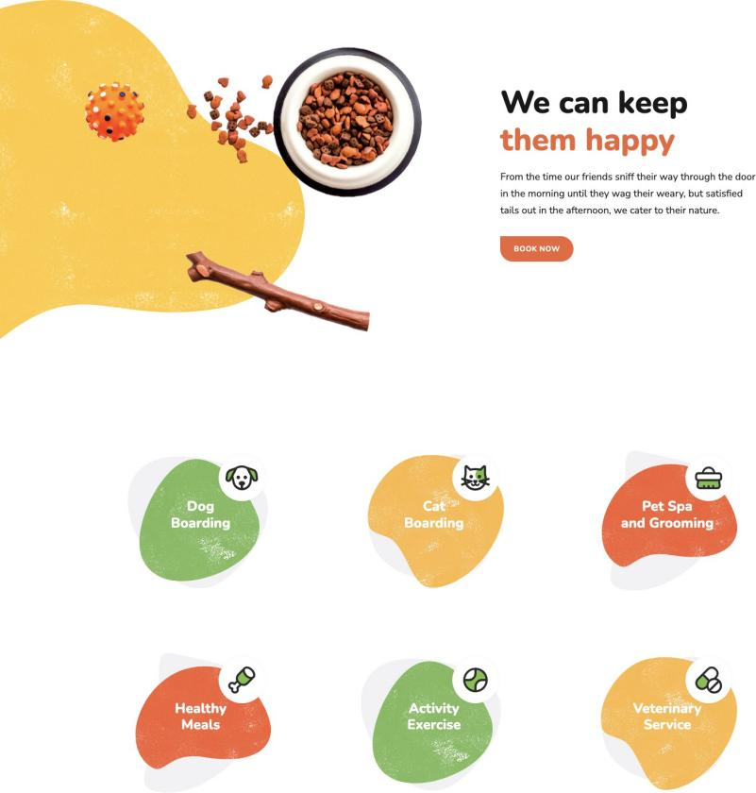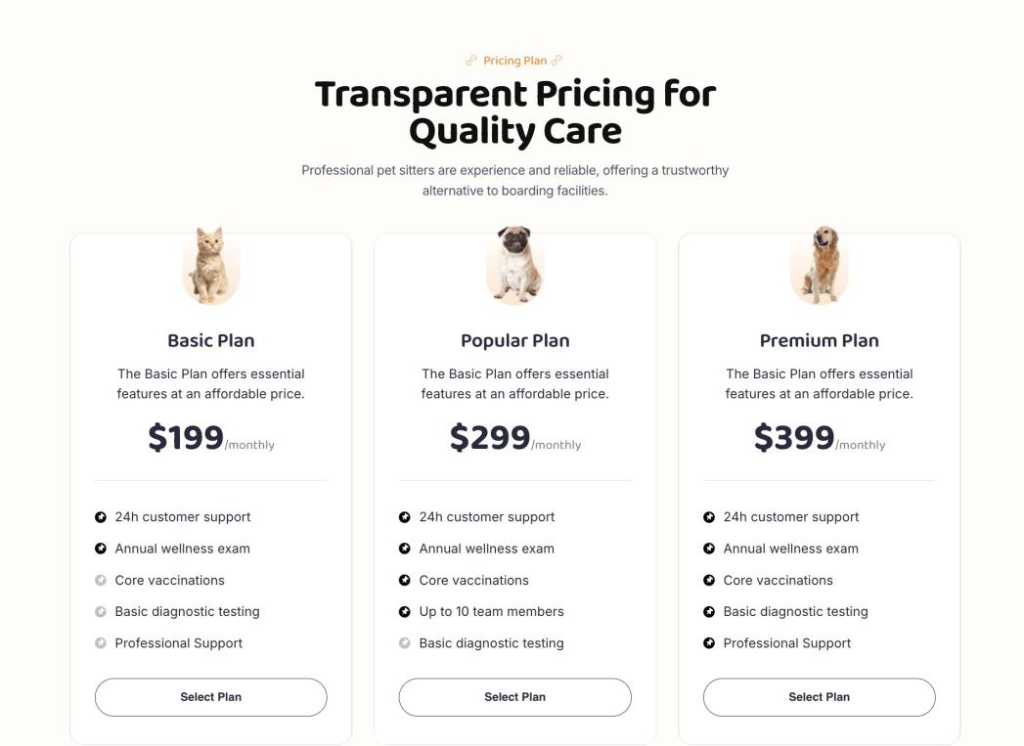

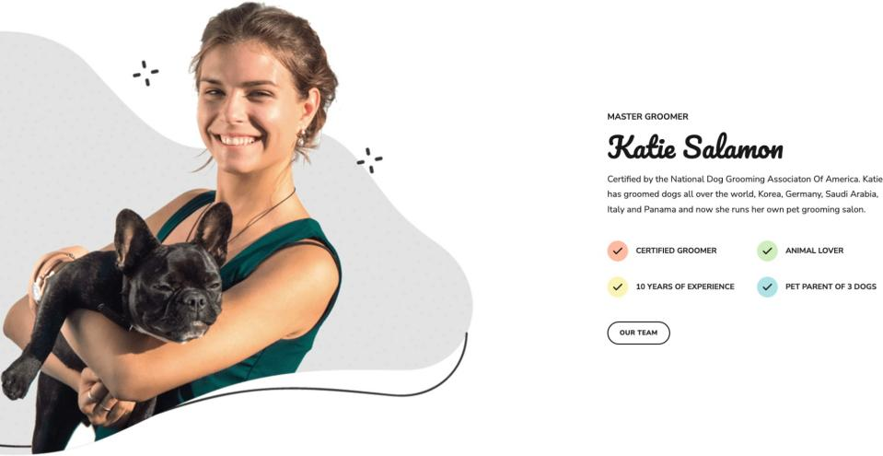

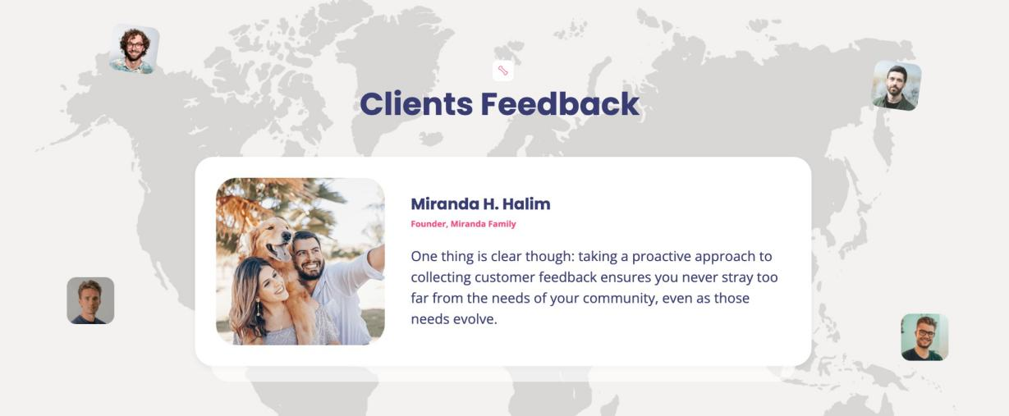

### Why Sieg Partners ?

* Sieg Partners is an ISO certified and Government registered marketing and IT development organization.
* We have 12+ years of experience with 55+ expert team

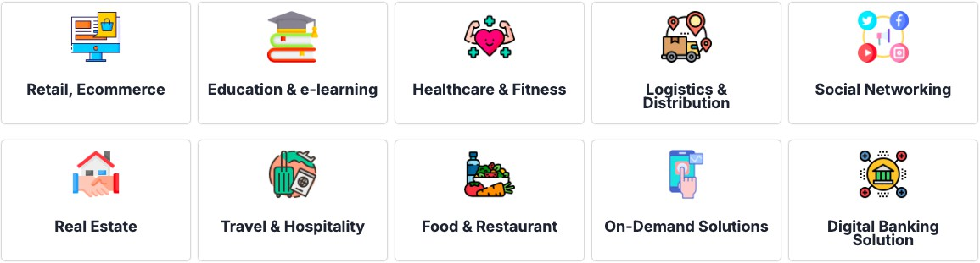

* "Customer First" culture helps us to deliver the right solution

— End of Document—